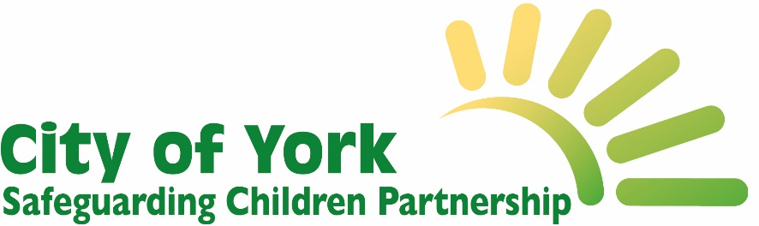
HEAT- lite: universal home environment screening tool
Adapted from the NYSCP Home Environment Assessment Tool (HEAT)¹.

To be completed jointly and with the consent of parents/ carers at the first visit to the home. This tool aims to enable open and supportive conversations and a shared understanding of the areas that may cause concern and enable support to be provided where required.

- Are there any safety hazards? E.g lack of safety equipment, medicines not secure, hoarding, loose cables/wires, pets that may pose a risk?
Parent/carer response and practitioner observations….

- Are there working smoke alarms, carbon monoxide detectors and safety hooks for looped blind cords?
Parent/carer response and practitioner observations….

- Is the home in a good state of repair? Consider both the exterior and interior of the home. Does the family have all essential items and furniture? Is the home warm and ventilated? Are there unpleasant odours that impact on the family or cause concern? Is the home overcrowded?
Parent/carer response and practitioner observations….

- Children’s safe sleeping environment to be observed to support safe sleeping recommendations
Parent/carer response and practitioner observations….

- Is there an appropriate area for food preparation and for preparing baby feeds and equipment sterilisation? Is there appropriate sterilisation equipment? (eg clutter free clean worktop, access to hand washing facilities)
Parent/carer response and practitioner observations….

- Is there anything that the parent/ carer, child or young person is concerned about at home or in the local area? For example anti-social behaviour or feeling unsafe at home or in the community?
Parent/carer/ child/ young person response and practitioner observations….

Refer to the Threshold Guidance and consult with your agency safeguarding team or the MASH (mash@york.gov.uk) if required to support decision making.
THRESHOLD DOCUMENT: https://www.saferchildrenyork.org.uk/Downloads/CYSCP%20Threshold%20Document%202022.pdf

